**Mon Carlo R. Alalan**

**WDD130 | W03 Project: Rafting Site - Planning Document**

**1. Site Logo**

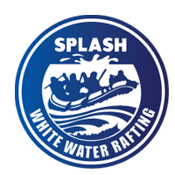

<https://byui-cse.github.io/wdd130-ww-course/resources/images/logos/z-splash.png>

**2. Color Palette**

**primary-color:** #00A6C3

**secondary-color:** #047699

**accent1-color:** #1C455D

**accent2-color:** #E2CC5A

**3. Typography**

**heading-font:** Merriweather

**text-font:** Roboto

**4. Coolors Palette URL Link**

<https://coolors.co/00a6c3-047699-1c455d-e2cc5a-3a3f3a>